BIT 4107-Mobile Application Development
ENHANCED PROFESSIONAL STUDENT LOGBOOK
Student name: ROY GICHINGA
Admission Number: BIT/2024/ 54477
School/Faculty: COMPUTING AND INFORMATICS
Program: DEGREE
Academic Year: THREE
Semester: TWO
Lecturer: MICHAEL NYORO
Phone Number:0768444898

SALES MANAGEMENT APP DOCUMENTATION
1. Introduction
This project involves the development of a Sales Management App using Flutter. The app allows users to register, store, and view student details.
2. Tools Used
Flutter & Dart – App development
Android Studio – SDK & Emulator
Visual Studio Code – Code editor
3. Installation & Setup
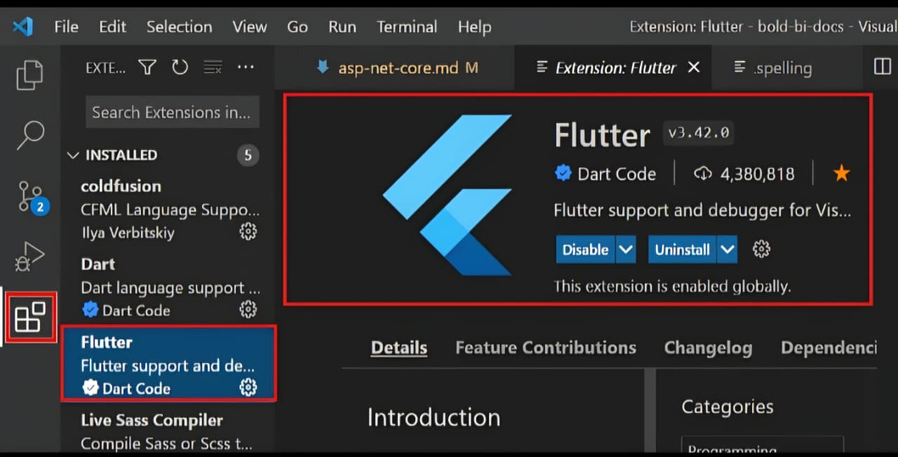
3.1 Flutter
Download Flutter SDK
Extract files
Add to system PATH
Run flutter doctor
Flutter installation / flutter doctor output

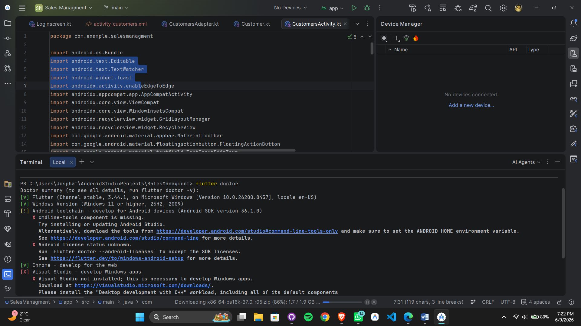

3.2 Android Studio
Install Android Studio
Install SDK tools
Create emulator

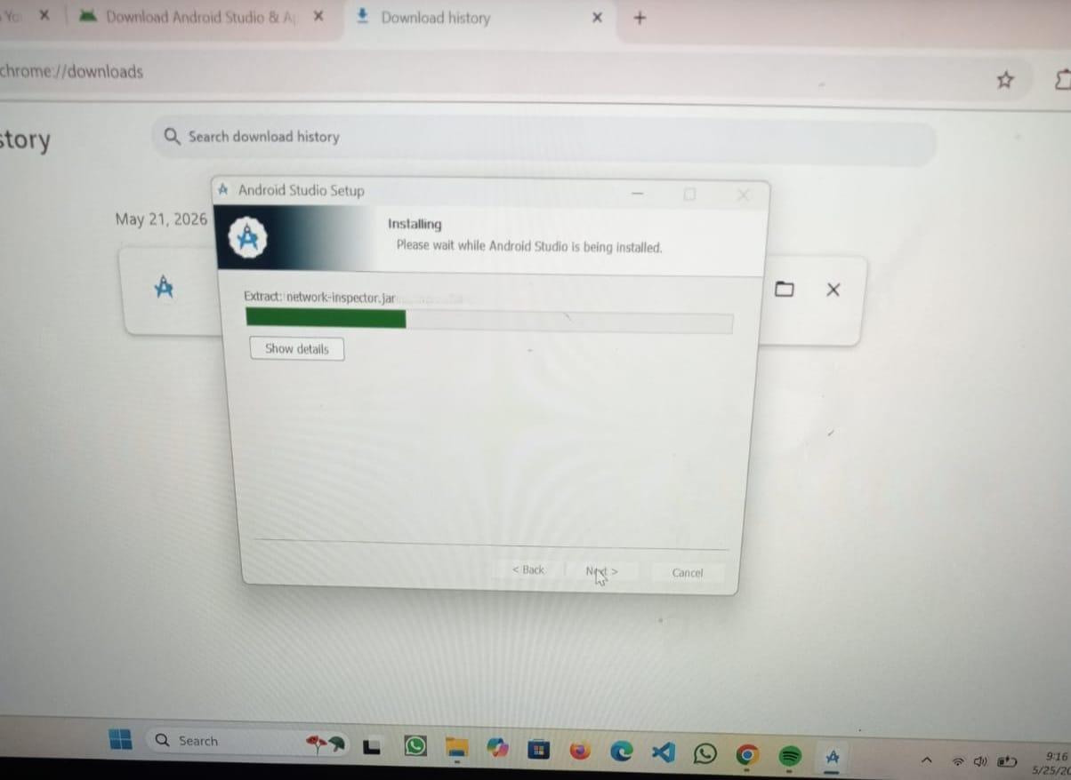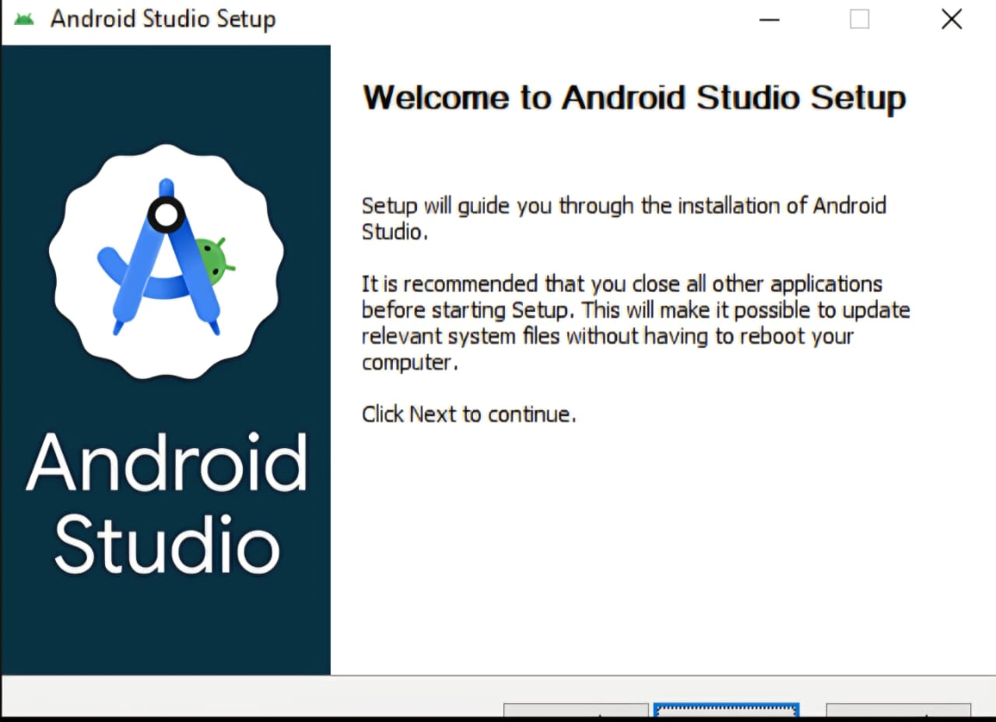
Android Studio installation / setup wizard
3.3 Visual Studio Code
Install VS Code

Install Flutter & Dart extensions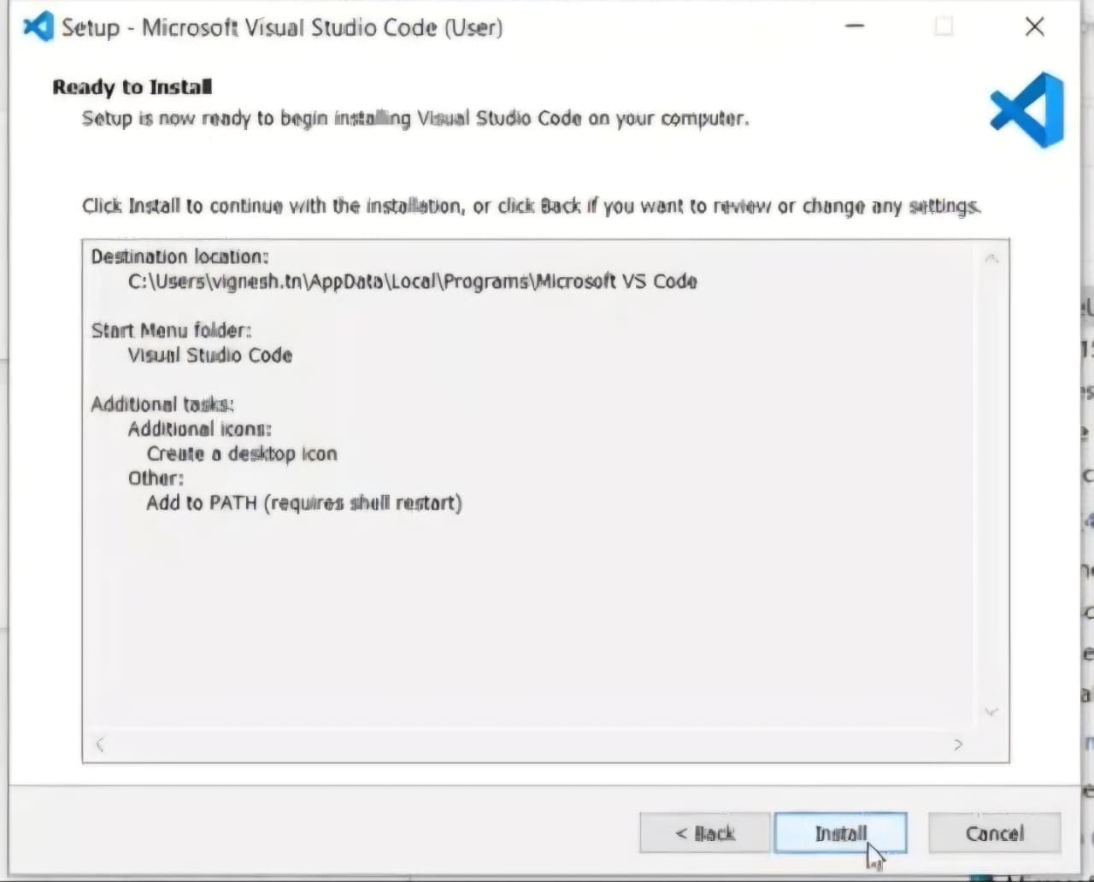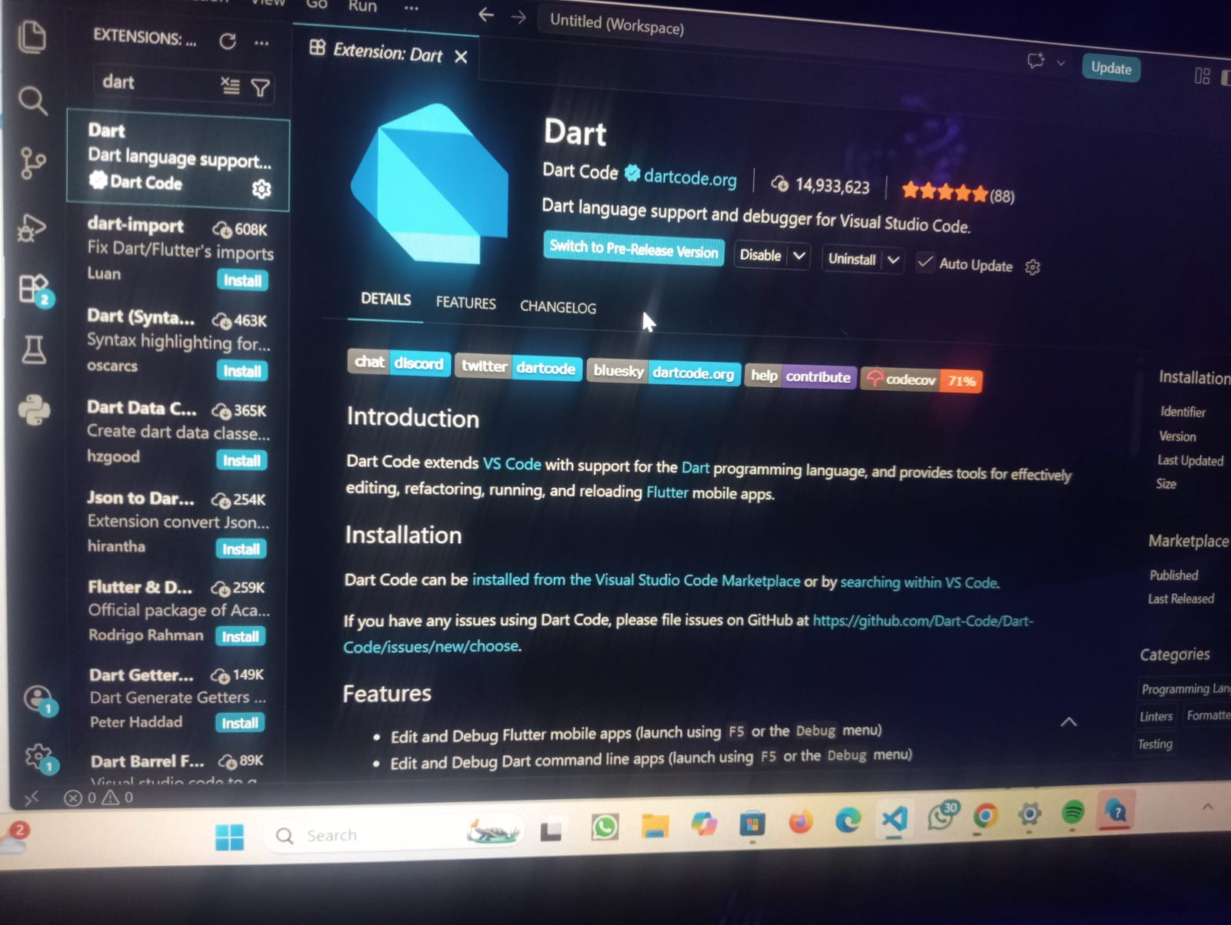
VS Code with Flutter extension
4. Project Creation
Open VS Code
Create Flutter project

5. Features
Login page
Add student
View students
Navigation between screens
6. Development
Used Flutter widgets for UI
Forms for data input
Stored data locally
Used Navigator for navigation
7. Running the App

Start emulator or connect phone
Running app on emulator/phone

Challenges
. Installation errors
. Emulator issues
. Slow build process
Solution: Used flutter doctor and installed missing components
9. Conclusion
The app was successfully developed and demonstrates basic mobile app development skills using Flutter.

PERSONAL REFLECTION
Installing Android Studio, Flutter, and the SDK Manager was a valuable learning experience that required patience and problem-solving. Although I encountered challenges such as configuration issues and installation errors, I learned how to troubleshoot problems, use terminal commands, and manage software dependencies. Successfully setting up the development environment improved my technical skills and confidence, preparing me for mobile app development.

WEEK 2: MOBILE DEVELOPMENT ENVIRONMENT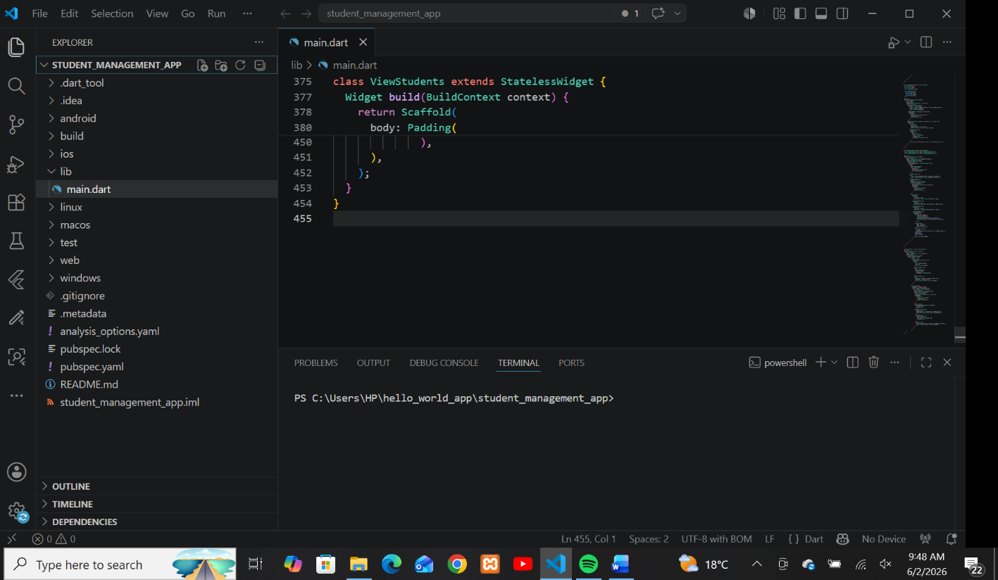
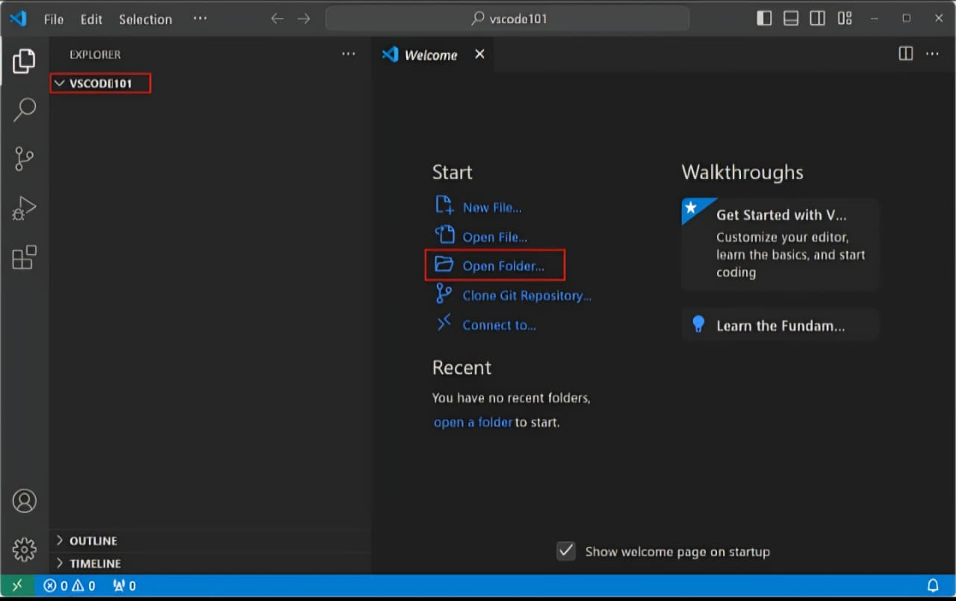

PERSONAL REFLECTIONS
Working with a mobile development environment was a valuable experience that helped me understand the tools and processes involved in app development. Setting up and configuring the environment required patience and attention to detail, especially when installing software, managing dependencies, and resolving errors. Through this experience, I improved my problem-solving and technical skills while gaining confidence in using development tools. Overall, the mobile development environment provided a strong foundation for creating, testing, and debugging mobile applications.

WEEK 3: USER INTERFACE DESIGN
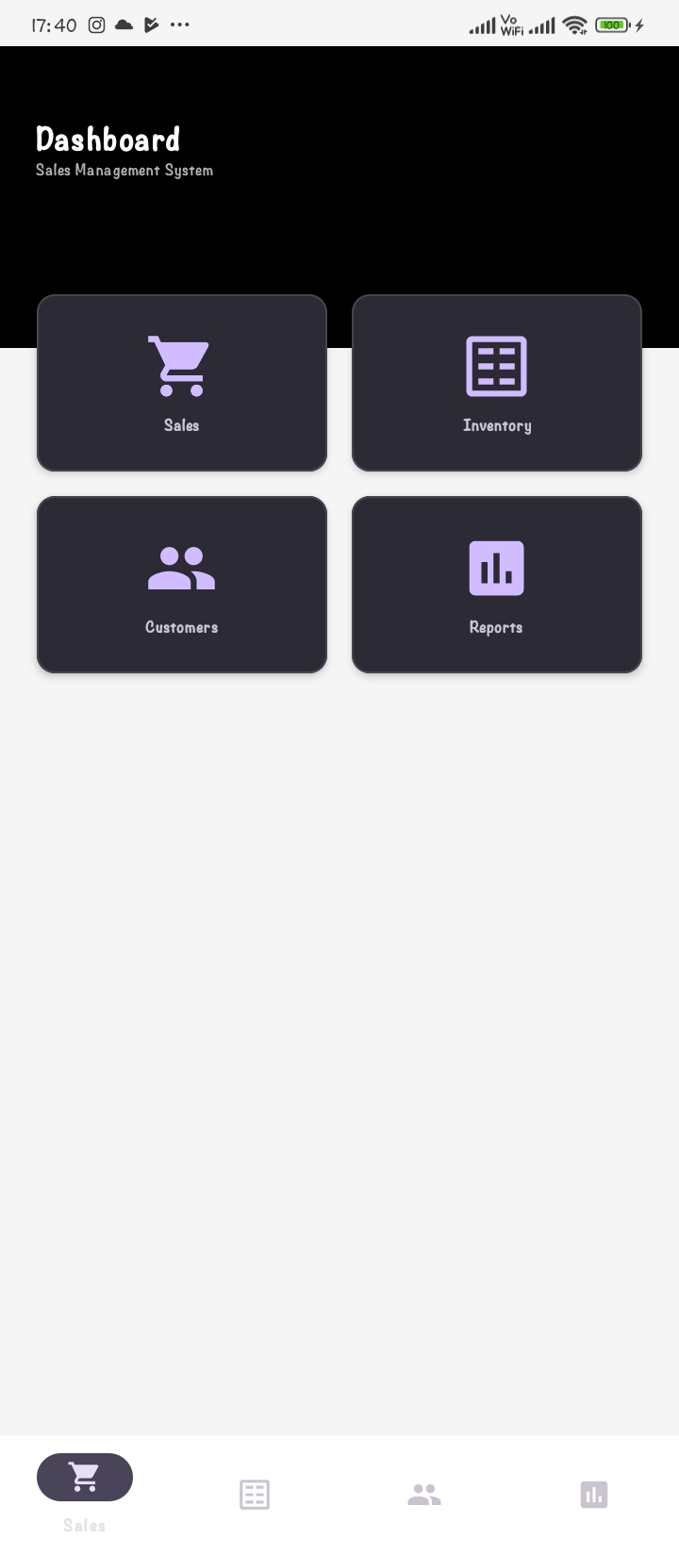

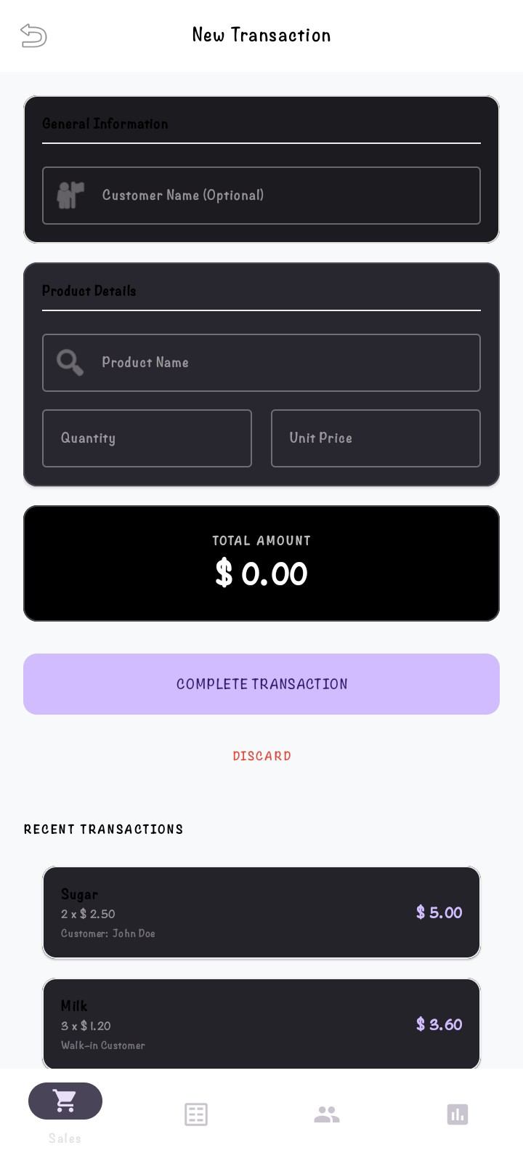
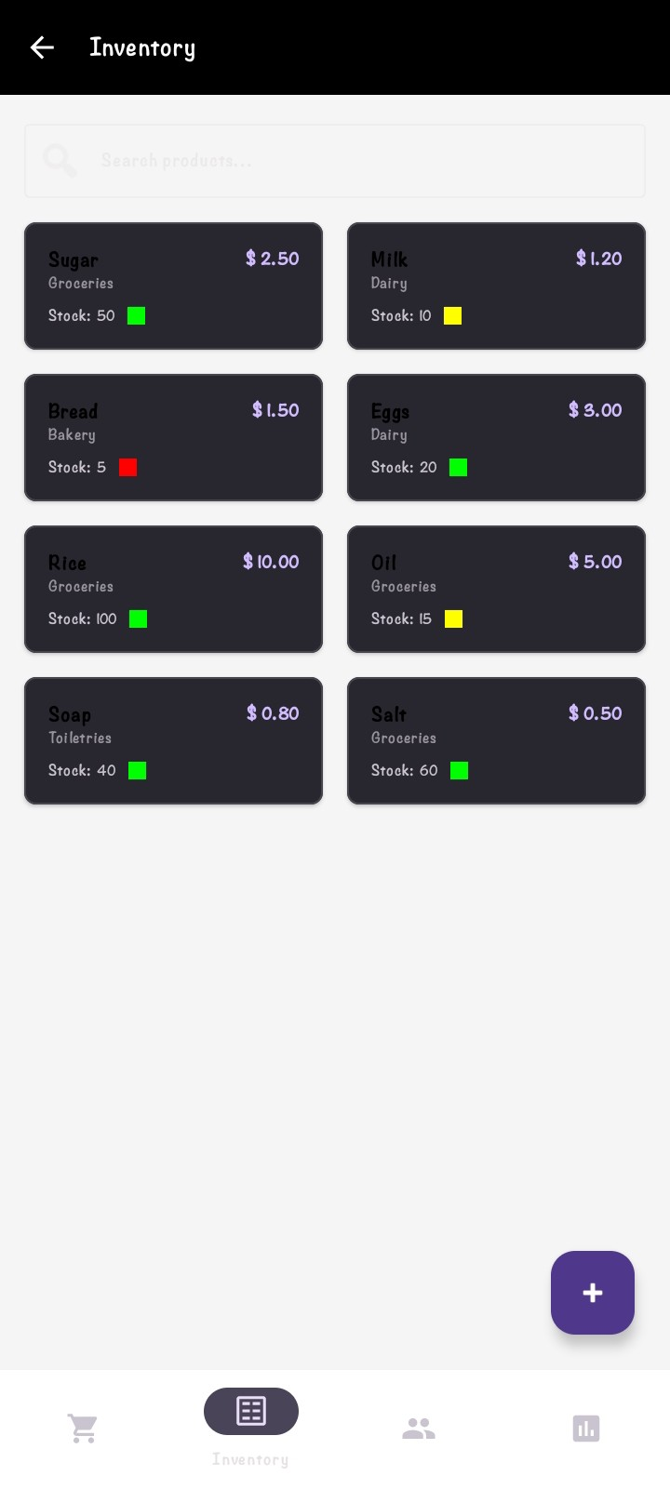
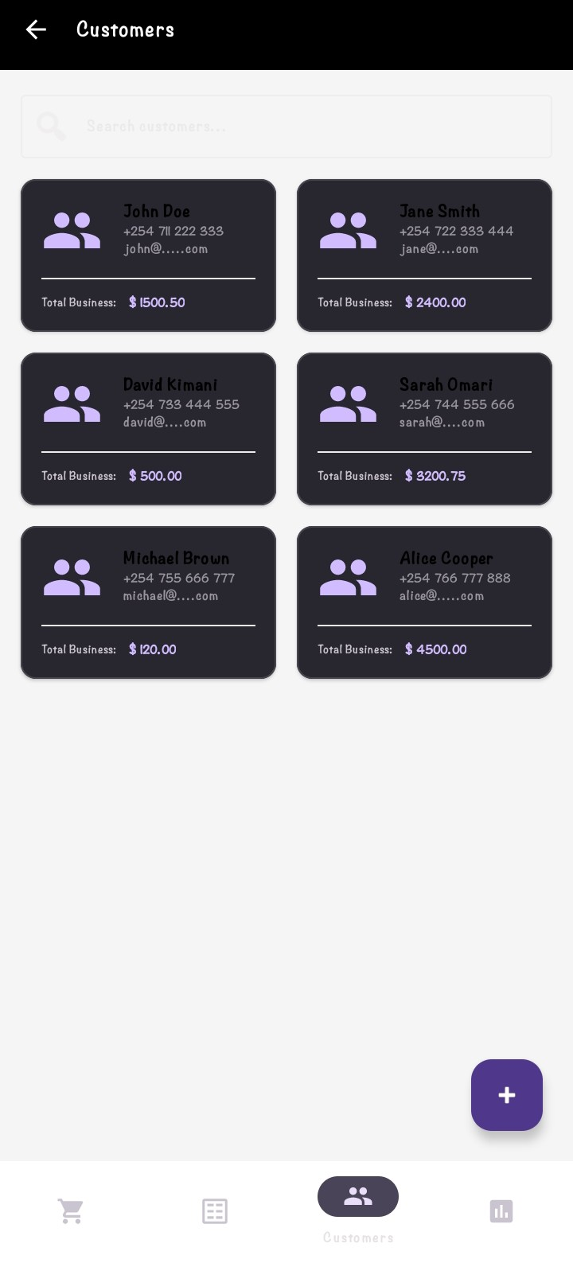
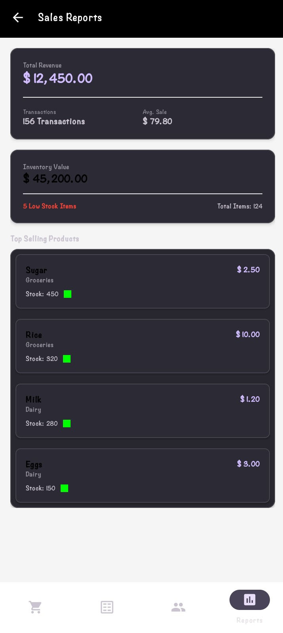
Personal reflection
Designing the sales management app user interface helped me understand the importance of creating a simple, attractive, and user-friendly design. I learned that effective UI design combines both visual appeal and functionality through the use of consistent layouts, appropriate colors, fonts, and icons. This experience improved my creativity, problem-solving abilities, and understanding of user-centered design principles, while highlighting the role of UI design in enhancing user satisfaction and application success.

Week 4: Event handling and user interaction



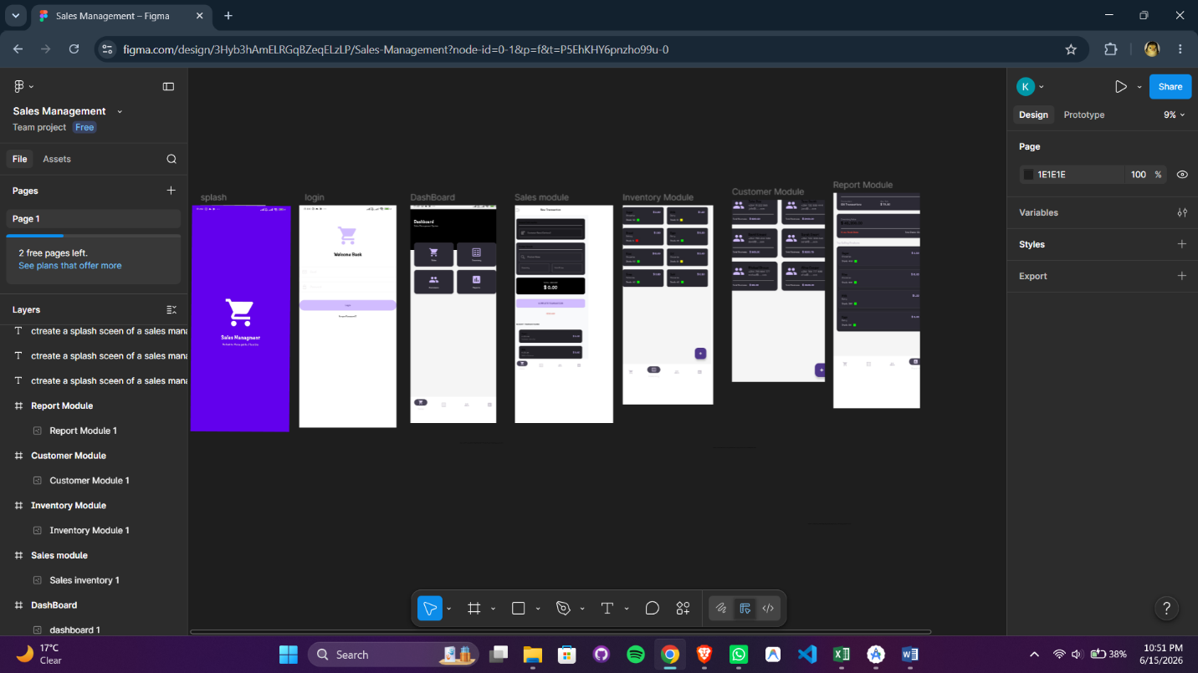
Personal reflection
Working on event handling and user interaction in the Sales Management app helped me understand how user actions trigger responses within the application. I learned the importance of creating responsive, intuitive, and user-friendly features that improve navigation and functionality. This experience strengthened my programming and problem-solving skills while highlighting the role of interactive features in enhancing the overall user experience.

Week 5: Data management


Week 6: Networking and APIs

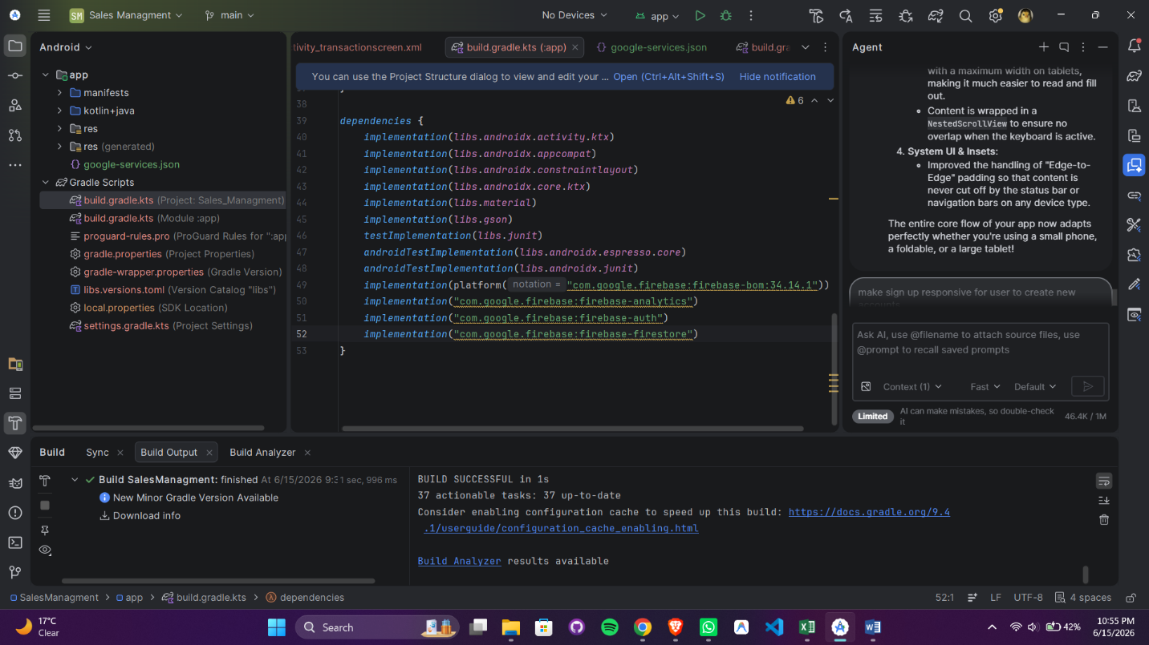

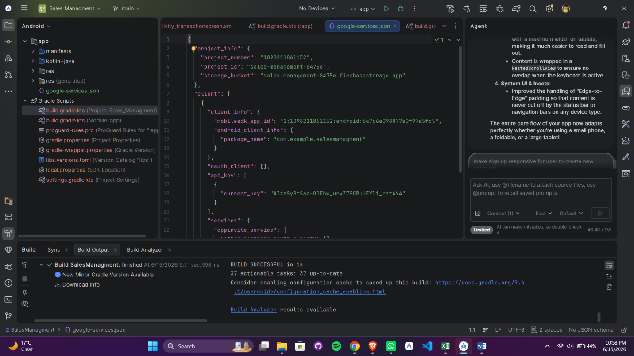

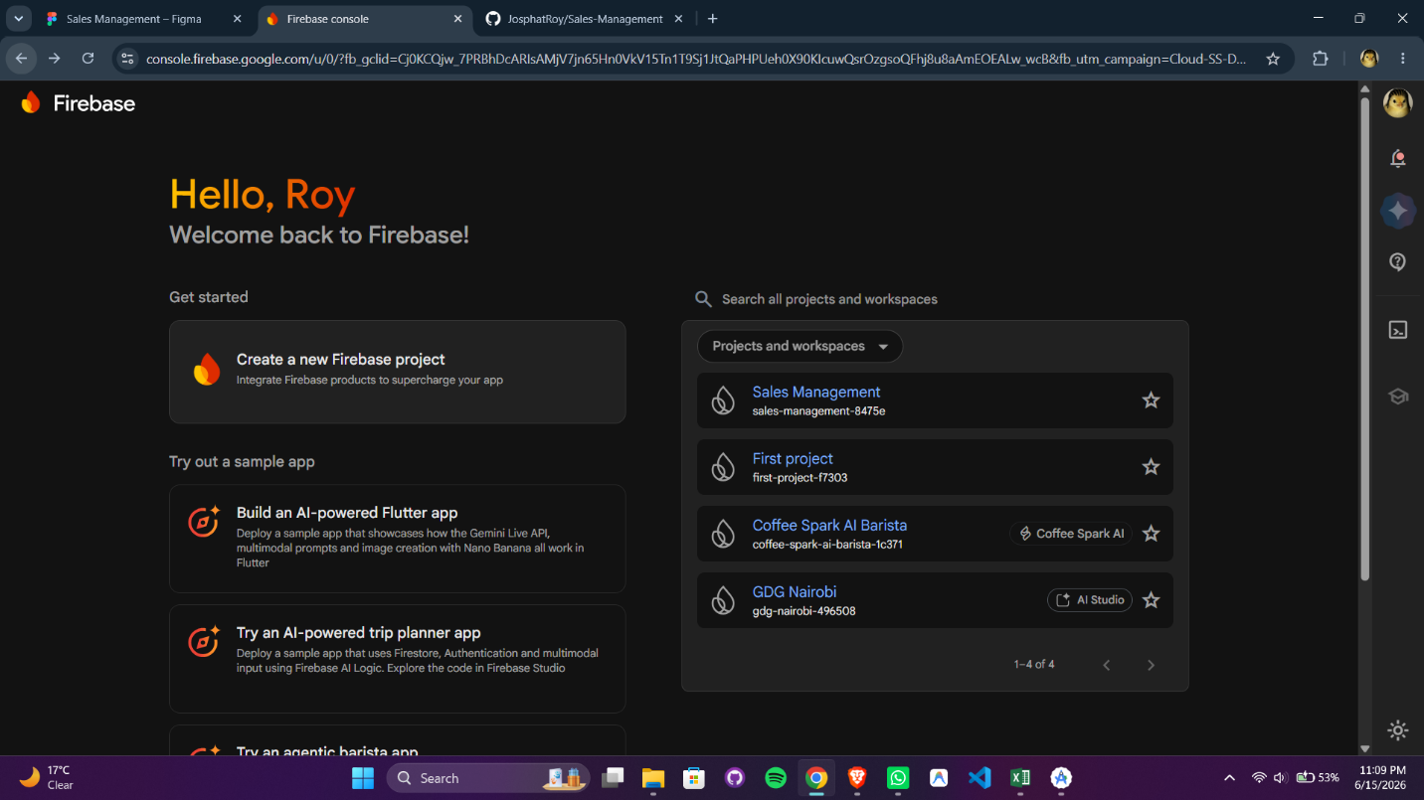

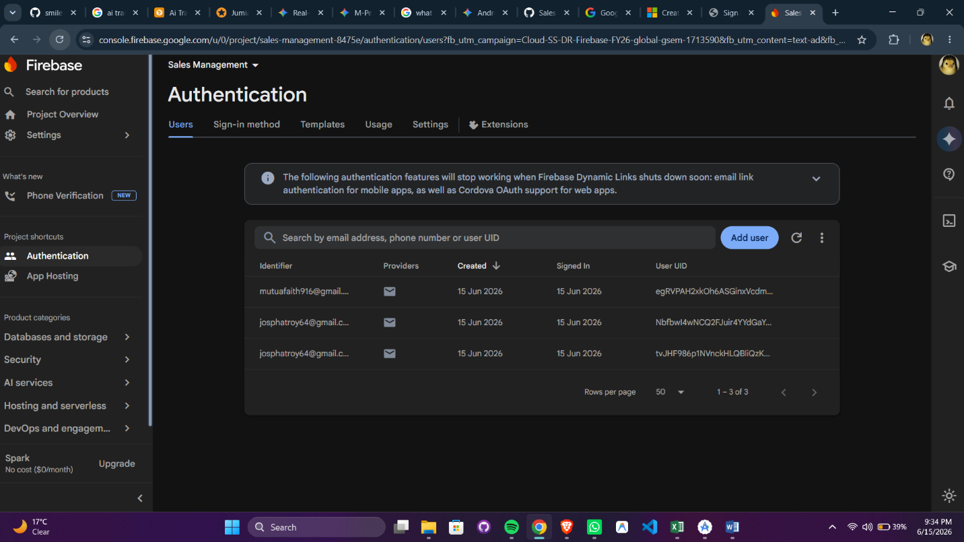

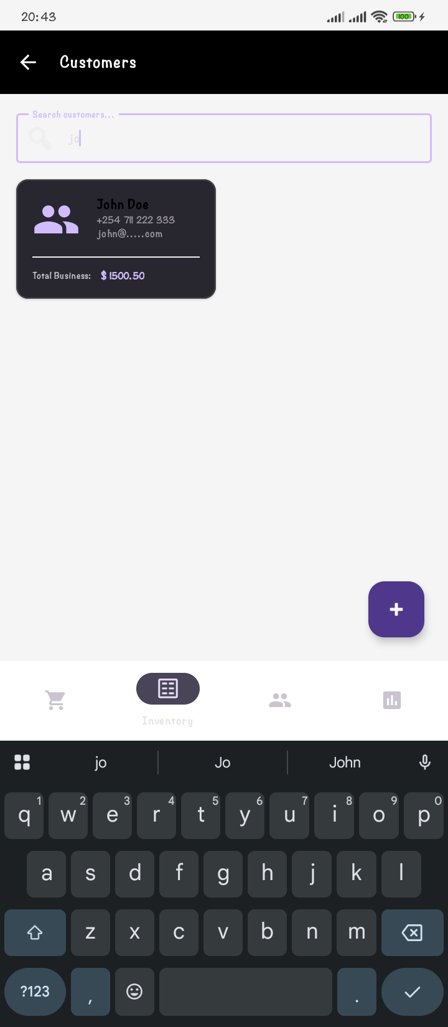

personal reflections
Working with networking and APIs in the Sales Management app helped me understand how applications communicate with external services to exchange data. I learned how APIs can be used to retrieve and update information such as: contact management, mobile field-tracking, and real-time automation. Implementing API connections improved my understanding of sending requests, handling responses, and managing data efficiently within the application.
This experience also taught me the importance of error handling, data security, and maintaining a stable internet connection to ensure a smooth user experience. Overall, working with networking and APIs enhanced my technical skills and gave me a better understanding of how modern mobile applications integrate with external systems to provide dynamic and personalized features.

